Software Requirements Specification
for
Space Potaters
Version 1.2 approved
Prepared by Travis Anderson,
Chris Birrenkott,
Josh Tan,
and Shambel Wako
Team Ramrod
Section 1
November 4, 2011
Table of Contents
Table of Contents ii
Revision History iii
1. Introduction 1
1.1 Purpose 1
1.2 Document Conventions 1
1.3 Intended Audience and Reading Suggestions 1
1.4 Product Scope 1
1.5 References 1
2. Overall Description 2
2.1 Product Perspective 2
2.2 Product Functions 2
2.3 User Classes and Characteristics 3
2.4 Operating Environment 3
2.5 Design and Implementation Constraints 3
2.6 User Documentation 3
2.7 Assumptions and Dependencies 3
3. External Interface Requirements 4
3.1 User Interfaces 4
3.2 Hardware Interfaces 4
3.3 Software Interfaces 5
3.4 Communications Interfaces 5
4. System Features 5
4.1 Moveable Space Shooter 6
4.2 Ability to Shoot with Space Shooter 6
4.3 Moveable Group of Enemy Space Potaters 7
4.4 Ability for Space Potaters to Fire Back 8
4.5 Appropiate Graphics for Space Potatoes and Shooter 8
4.6 Protective Barriers with Damage Feedback 9
4.7 Animations for Potaters and Shooter Death 10
4.8 Lives System 11
4.9 Score/Record System 11
4.10 Shootable Bonus Potaters Across Top of Screen 12
4.11 Variability in Difficulty 12
4.12 Menu System 13
4.13 Sound Effects 14
4.14 Ability to Pause 15

5. Other Nonfunctional Requirements 15
5.1 Performance Requirements 15
5.2 Safety Requirements 15
5.3 Security Requirements 15
5.4 Software Quality Attributes 15
5.5 Business Rules 16
6. Other Requirements 16
Appendix A: Glossary 16
Appendix B: Analysis Models 16
Appendix C: To Be Determined List 16

Revision History
Name | Date | Reason For Changes | Version
Team Ramrod | 10/05/2011 | Initial document. | 1.0
Team Ramrod | 10/17/2011 | Section 1.2, 1.5, and 4.12 revised. Screenshot added to Section 3.1. | 1.1
Team Ramrod | 11/04/2011 | Removed all references to an applet-based game implementation. Added the in-game functional key ‘Esc’. Modified the menu to include an instructions sub-menu. | 1.2

Introduction

Purpose
The software requirements specified in this document are for the Java-based game “Space Potaters”. Space Potaters is a variation of the classic game known as Space Invaders. This game is to be fully functioning and should behave similar to the original game, but it should be equipped with a different theme than the original game. Instead of fighting space aliens, the user will fight attacking forms of potatoes, such as French fries, baked potatoes, mashed potatoes, etc. The software specified in this document is version 1.2 of Space Potaters.

Document Conventions
This document is formatted in such a way that the headings for major ideas or general concepts have a larger font than minor ideas or more specific concepts. This formatting is aided by the use of a hierarchical number system (e.g. Section 4.4.1 focuses on a specific aspect of Section 4.4). Additionally, the most important topics that are addressed in this requirements specification (those topics that appear in the Table of Contents) are formatted in boldface.

Intended Audience and Reading Suggestions
This document is mainly focused at developers and project managers. It is recommended that this document be read sequentially. Project managers should especially take note of the required features and their individual priorities.

Product Scope
As stated in section 1.1, this software is a variation of the game Space Invaders. In this game, different styles of enemy potatoes will be lined up in rows based on type. They will move spot by spot across a grid from left to right, then drop down one level, move from right to left, drop down one level, and then repeat this process again until they reach the bottom. The aim of the game is to control your character across the bottom of the screen and shoot the potatoes before they reach the bottom. If the user fails to eliminate all of the enemy potatoes before they reach the bottom of the screen, you game is over. If the user gets shot by an enemy potato, he will lose a life. The user will begin with three lives. If all three lives are lost, the game is over.

The purpose of this game is to provide an entertaining and fun experience for the user. While no fee should be directly charged to play the game, income can be generated through advertisements that are placed on the website where the game is hosted, if user traffic is large enough.

References
The following resources were used in the creation of this software project:

- This software requirements specification was created using the SRS template “SRS_Template_IEEE.doc”, provided in the Projects subfolder of the Blackboard page for the NDSU course CSCI 161. This document was copyrighted in 1999 by Karl E. Wiegers, with permission granted to use, modify, and distribute it.

- Anderson, J., & Franceschi, H. (2012). Java illuminated: An active learning approach (3rd ed.). Sudbury, MA: Jones & Bartlett Learning.

- Davison, A. (2005). Killer game programming in Java. Cambridge, MA: O’Reilly Media.

- Glass, G. (n.d.). Space invaders 101 – An accelerated Java 2D tutorial. Retrieved from http://www.cokeandcode.com/info/tut2d.html.

Overall Description

Product Perspective
This product is a recreation of the popular game Space Invaders. It does not rely on any other existing software system, but should instead be a self-contained product.

Product Functions
The major functions of this product can be divided into the following features:

- The space shooter controlled by the user should be placed near the bottom of the screen and should be moveable in a horizontal fashion.

- The space shooter should have the ability to fire projectiles at enemy potatoes.

- The enemy space potatoes (“space potaters”) should consist of an array of potaters and should move automatically according to a specific pattern, always moving progressively downwards.

- The enemy space potaters should also have the ability to fire back at the space shooter, and this firing should be activated in a pseudo-random manner.
- Appropriate graphics for both space potaters and the space shooter should be implemented, in order to realize a different theme than the original Space Invaders.
- Protective barriers should be placed near the bottom of the screen to enable different strategies of playing the game. These barriers should break apart as they take damage.
- Animations should be implemented for the space potaters and space shooter death. A simple looping animation will be sufficient.
- A lives system should be included to increase vary the game difficulty. Lives are lost by whenever the space shooter is hit by an enemy projectile.
- A score and record system should be implemented. A player’s score is increased when he destroys enemy potaters. A record system involving a player’s score will increase the replay value of this game.
- Bonus space potaters should periodically hover across the top of the screen. Shooting these results in bonus points which increase the player’s score.
- The difficulty should be varied within a level, as the space potaters near the bottom of the screen. It should also be varied across different levels, increases as the player progresses.
- A menu system should be included with various options. This menu will also display user controls before the start of a game.
- Sound effects will help to realize a specific and unique theme for this game.
- The ability to pause will allow the user to temporarily freeze gameplay and return later.

User Classes and Characteristics
The main user class will be the casual PC gamer between the ages of 13 to 25. Another smaller user class may be people between ages 30 to 45 who grew up playing the original Space Invaders when it was first released in 1978. It takes no previous experience or education to be able to operate this system. The instructions will be displayed in the beginning and are easily followed, making a fun and entertaining product for all ages.

Operating Environment
This software is a standalone game that can work on any Operating System (e.g. Windows 7, Mac OSX) that is installed with a modern Java Runtime Environment. The user will need access to the Internet to initially download the Java application. After this initial download, this software can be run locally.

Design and Implementation Constraints
Time available to work on this project is the largest constraint placed on the development of this software. This software is being developed as a required project for a semester-long course. Deadlines for various components of this software’s developments will limit the quality and quantity of software features implemented in the final product. In addition, developers will only be allowed to use the Java programming language for this project.

User Documentation
Information on controlling keys will be explained within the in-game instructions sub-menu.

Assumptions and Dependencies
This software will reuse and heavily rely on the built-in Java class libraries.

External Interface Requirements

User Interfaces
Outside of playing the actual Space Potaters game, the user will interface with the software simply by choosing the appropriate option, represented by a clickable button.

Inside the actual Space Potaters game, the user will interface with the software by sending commands to the space shooter to either move left or right, or shoot. The user will also be able to pause the game. Figure 1 shows the general user interface for within the Space Potaters game.

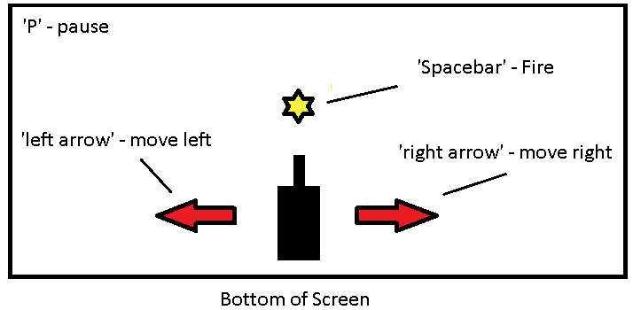
Figure 1:

Hardware Interfaces
The hardware interface for this game can be split into two components: the mouse-based user interface for the menu and the keyboard-based user interface for playing the game.

The main menu will include the options described in Section 4.12. The user will choose the different options by using a mouse (or touchpad). By left clicking once on any of the option buttons, the user will activate that option.

The keyboard-based user interface will be implemented whenever the user is playing the actual Space Potaters game. The only keys that will affect the software during this stage of the software are the following:

- ‘P’ – used to pause the game
- ‘Esc’ – used to exit the game and return to the main menu
- the left and right arrow keys – used to navigate the space shooter
- the spacebar – used to fire projectiles from the space shooter

The relevant keys are highlighted below, in Figure 2.

Figure 2:

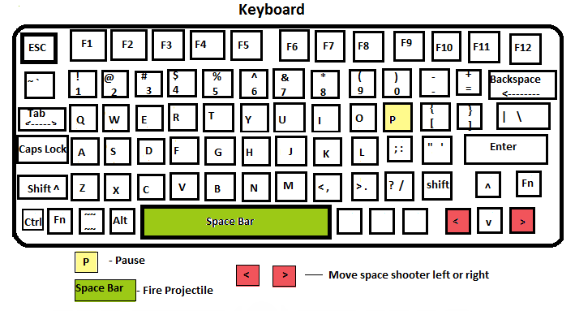

Software Interfaces
This product will interface with the Operating System that it is running on locally through a Java application. The software will run on the Java virtual machine (Java Runtime Environment) that is installed on the Operating System.

Communications Interfaces
Not applicable.

System Features
Figure 3 shows what a snapshot of the final product should resemble:

Figure 3:
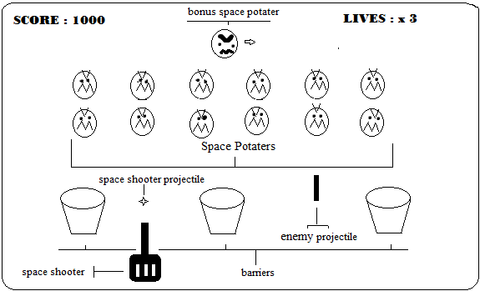

Moveable Space Shooter
4.1.1 Description and Priority
The space shooter should have the ability to move horizontally across the bottom of the screen. This movement should be fluid and should correspond to certain keys on the standard keyboard.

This functionality is of high priority. The ability to move the space shooter horizontal is required for even a primitive version of this game.
4.1.2 Stimulus/Response Sequences
The left arrow on the keyboard corresponds to the space shooter moving left on the screen. The right arrow on the keyboard corresponds to the space shooter moving right on the screen. The shooter should continue moving in a certain direction as long as the key corresponding to that direction is held down or until the left or right edge of the screen is reached.
4.1.3 Functional Requirements
Not applicable.

Ability to Shoot with Space Shooter
4.2.1 Description and Priority
The space shooter should have the ability to shoot projectiles vertically towards the top of the screen. These projectiles should move in a straight line vertically from the original starting point, which is at the top of the space shooter. The projectiles should continue until either they disappear off the top of the screen or they collide with some other entity.

This feature if of a high priority and must be implemented for a meaningful game of Space Potaters to be played.
4.2.2 Stimulus/Response Sequences
The signal for the space shooter to shoot is the pressing of the spacebar key. There should only be one projectile (originating from the space shooter) on the screen at any given time. This means that if the projectile is shot and does not collide with any other entity on the screen, then another projectile cannot be shot until the first projectile disappears off the top of the screen. If the projectile encounters some other entity before this (an enemy or barrier or enemy projectile), then the projectile will disappear (i.e. explode) and another projectile will be immediately available to be shot by the space shooter.
4.2.3 Functional Requirements
Not applicable.

Moveable Group of Enemy Space Potaters
4.3.1 Description and Priority
An array of enemy entities, or space potaters, should move down the screen as time progresses. At the beginning of the game, they should be located near the top of the screen. These space potaters should move as a single group and their movement, unlike that of the space shooter, should not be continuous, but rather in discrete steps. These steps will correspond to the passing of a certain short period of time. The movement pattern is one in which the space potaters move horizontally in steps in a single direction until the left or right edge of the screen is a reached by a space potater. At this point, the entire set of space potaters should move vertically down one step and then continue horizontal movement in the opposite direction. This pattern is repeated until the space invaders reach the bottom of the screen.

It is important that the rate of space potater movement be slower than the rate of space shooter movement. This will allow the space shooter to overtake the enemy.
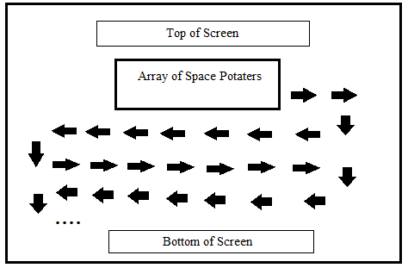
The general movement pattern is illustrated in Figure 4:
4.3.2 Stimulus/Response Sequences
The space potaters should move independently from any user input as long as the game is running. Their movement corresponds to a timer and should be executed once every time a certain short period of time passes.
4.3.3 Functional Requirements
REQ-1: A timer that can be called upon repeatedly to coordinate the space potater movement.

Ability for Space Potaters to Fire Back
4.4.1 Description and Priority
The space potaters should also have the ability to fire back at the space shooter, although this ability should be restricted to space potaters that do not have any other space potaters underneath them. To begin with, this will consist of the bottom row of the space potaters. As these space potaters are shot and destroyed by the space shooter, the space potaters above them will gain the ability to shoot projectiles.

As in the case of projectiles shot by the space shooter, a space potater should only have a single projectile (that originated from it) on the screen at a given time. The space potater must wait until that projectile travels off the bottom of the screen or hits some other entity before it is allowed to shoot another projectile.

This feature is of medium priority. It is not absolutely necessary in order to implement a proper space potater game, since downward movement by space potaters alone provides some degree of challenge to the game user – i.e. the user will still have to shoot the space potaters before they reach the bottom of the screen in order to avoid losing the game. However, implementing this feature will increase the difficulty (and excitement) of the game.
4.4.2 Stimulus/Response Sequences
The firing of projectiles by space potaters will not be prompted by any user input. Instead, the projectiles will be fired randomly.
4.4.3 Functional Requirements
Not applicable.

Appropriate Graphics for Space Potatoes and Shooter
4.5.1 Description and Priority
In early stages of the game, the visual representations of space potaters and the space shooter will likely be blocks. This should be upgraded before the final product so that space potaters take some form that more resembles of a potato. Similarly, the space shooter should appear as a creature similar to Gollum, the potato-hating character from J.R.R Tolkien’s novel The Lord of the Rings.

This feature is of medium priority. While not necessary to implement the game logic, it is important to add some character to Space Potaters that differentiates it from the more generic Space Invaders game. By making this game potato-themed, the user will have a reason to switch from playing Space Invaders to Space Potaters. Also, the name of this game will not make sense unless some sort of potato theme is realized in the game.
4.5.2 Stimulus/Response Sequences
Not applicable.
4.5.3 Functional Requirements
REQ-1: Appropriate images files for space potaters and the space shooter that can be used in the game. These will likely need to be created specifically for this project.

Protective Barriers with Damage Feedback
4.6.1 Description and Priority
Protective barriers near the bottom of the screen will provide shelter for the space shooter from the oncoming projectiles of enemy space potaters. These barriers will take physical damage and break apart as they hit by projectiles, both from the enemy space potaters and from the space shooter. As the barriers break apart, holes will form in the barriers that allow projectiles to pass through. These barriers can fully destroyed if hit with enough projectiles.

The barriers can implement the space potater theme by taking the form of French fry containers, as shown in Figure 5:

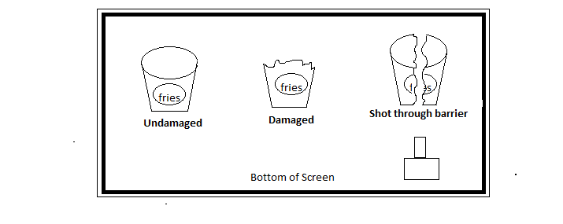
Figure 5:
The priority for the implementation of protective barriers with damage feedback is medium. It’s not necessary for a functioning game, but it will allow for new strategies in beating the game.
4.6.2 Stimulus/Response Sequences
These barriers will take damage any time a projectile hits one of them. This includes when the user presses the spacebar to trigger a projectile by the space shooter. If the user is not careful, he can make the game more difficult for himself by decreasing the amount of cover he has from enemy fire.
4.6.3 Functional Requirements
Not applicable.

Animations for Potaters and Shooter Death
4.7.1 Description and Priority
Animations for the space potaters and space shooter will make the game more interesting and aesthetically pleasing. The following animations should be provided:

- Space potater movement animation:
The space potaters should alternate between two images each time they take a step in a direction, whether that is left, right, or down. This alternation between two images should give the appearance of discrete space potater movement.

- Space potater death animation:
When a space potater is destroyed, his image should be replaced with that of an explosion. The explosion image should be very briefly shown and then removed. This will give the appearance of flash of light or fire.

- Space shooter death animation:
When the space shooter is destroyed, a more elaborate death animation should be displayed than the case for space potater death. There is more time to perform animation in the case of space shooter death, because unlike space potater death, a dead space shooter does not need to disappear quickly in order to allow another entity to move to its place.

Animations are a low priority. The game logic does not rely on them and they are not relied upon by any critical game functioning.

4.7.2 Stimulus/Response Sequences
Space potater movement animation does not rely on any user input. It is performed automatically for each movement step of the space invaders. A space shooter death animation is triggered whenever the user does not avoid getting hit by a space potater projectile or whenever the space potaters reach the bottom of the screen. A space potater death animation occurs whenever a projectile fired by the user makes contact with a space potater.
4.7.3 Functional Requirements
REQ-1: Appropriate sets images files for space potaters and the space shooter that can be used in the game. These will likely need to be created specifically for this project.

Lives System
4.8.1 Description and Priority
A live system should be implemented that allows a user a limited number of attempts at beating the game. If the user fails more than allotted number of lives, the game is permanently over and must be restarted from the beginning. The number of available lives transfers over to any new levels as the player progresses through the game.

The priority of a live system is classified as medium. Its existence will make the game more challenging and affect gameplay strategy, since users will be less likely to take risks if they are low on lives.
4.8.2 Stimulus/Response Sequences
Whenever a player fails to move out of the way of an enemy projectile, a life is lost. If no more lives exist and a player’s space shooter is destroyed, then the game is over.

Note: If the space potaters reach the bottom of the screen, the game is over, regardless of how many lives the player has left. However, if a player has extra lives and dies, then the gameplay will pause temporarily and continue in the same state as before, minus one life.
4.8.3 Functional Requirements
Not applicable.

Score/Record System
4.9.1 Description and Priority
A labeled number listed at the top of the screen should display the current score of the player. Player should gain points only for destroying enemies. Players can not lose points. Space potaters that were originally located high up towards to the top of the array are worth more points that space potaters that were originally located towards the bottom.

Also, a record system should be implemented. Whenever a player losing the game (not just loses a life), his score will be compared to a file containing the top ten scores ever achieved. If his score is high enough to place in the top ten, he will have the opportunity to input three letters corresponding to the initials of his name. This entry will be recorded in the file and saved for future games.

This is a low priority feature. It’s not necessary for a functioning game, but it’s inclusion in the final product will provide additional incentive for the player to keep playing and will increase replay value.
4.9.2 Stimulus/Response Sequences
Destroying space potaters increases a player’s score. Upon losing game and if the score places in the top ten ever achieved, the player will use the keyboard to enter three letter characters corresponding to his name.
4.9.3 Functional Requirements
REQ-1: The ability to read/write data from a text file that stores the records.

Shootable Bonus Potaters Across Top of Screen
4.10.1 Description and Priority
Bonus space potaters will randomly float horizontally across the top of the screen, independent of the main array of space potaters. These bonus potaters will move faster at a faster rate than the regular space potaters, but not as fast as the space shooter. They will also be worth more points than any of the regular space potaters.

This is a low priority feature. It is not necessary for any game logic, but will provide an additional challenge.
4.10.2 Stimulus/Response Sequences
The bonus space potaters will randomly drift across the top of the screen. The player can use the spacebar to fire projectiles at the bonus potaters, in the same manner as he fires at regular space potaters. However, since the bonus space potaters move at a faster rate, he will have to lead the potater more when shooting to take this into account.
4.10.3 Functional Requirements
REQ-1: Bonus space potaters should be easily distinguishable from regular space potaters, not just by observing their behavior, but also by their icon. This will require another image file that will likely have to be specifically created for this project.

Variability in Difficulty
4.11.1 Description and Priority
There are two ways to vary the difficulty:

- Increase the difficulty within a level:
As the space potaters get closer to the bottom of the screen, the time between their movement steps should decrease. This corresponds to faster overall movement by them, which will in turn make them a harder target to hit.

- Increase the difficulty between levels:
If a player successfully destroys all space potaters before they reach the bottom of the screen and before he runs out of lives, he has beaten that level of the game. By having multiple levels, the game can challenge ambitious players and increase replay value.

Levels should increase in difficulty as they are encountered. This is done in the following two ways:

- Increase the tendency for space potaters to shoot back. This will result in more enemy projectiles that the player has to avoid and destroy the protective barriers more quickly.
- Increase the initial rate of movement for the space potaters (which will increase inside the level as well). Faster targets are harder to destroy.

This is a low priority feature, since it’s not an essential component of the game.
4.11.2 Stimulus/Response Sequences
Within a level, space potater rate of movement will increase over time (and as they get closer to the bottom of the screen).

Upon completion of the current level, a new level will be introduced with space potater initial speed and tendency to shoot both increased.
4.11.3 Functional Requirements
Not applicable.

Menu System
4.12.1 Description and Priority
Without the presence of a functional menu system, the user will not be able to navigate between the different components of the game (playing the game, viewing high scores, exiting the program, etc.). Therefore, a menu system must be implemented if components other than playing the actual game are to be used. The options in the main menu should contain the following:

- Quickstart a game (with default settings)
- See high scores/game leaderboard
- Choose game difficulty
- View Instructions
- Exit

The priority of this feature is high only if features such as the leaderboard and varying difficulty have been implemented, otherwise it is low.

Figure 6 shows the structure of the game menu and the results of choosing the different options.

4.12.2 Stimulus/Response Sequences
- If a player chooses the “Quick Start Game” option, he should be forwarded to the Space Potaters game with a default (medium) difficulty.
  - After finishing the game, the game menu should be displayed again.
- If a player chooses the “Choose Difficulty” option, he should be forwarded to the Space Potaters game with the chosen difficulty setting.
  - After finishing the game, the game menu should be displayed again.
- If a player chooses the “View Leaderboards” option, he should be presented with a list of top players and their records.
  - After exiting the leaderboard screen, the game menu should be displayed again.
- If a player chooses the “Exit Program” option, the program should exit completely.

4.12.3 Functional Requirements
Not applicable.
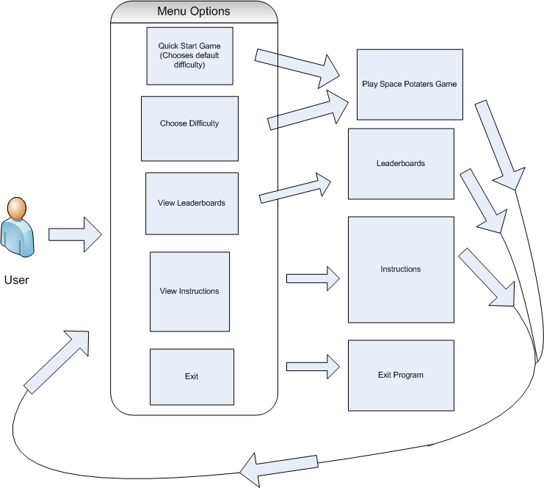
Figure 6:

Sound Effects
4.13.1 Description and Priority
Specific and distinct sound effects should be assigned to the various game events. These sound effects should be appropriate to the action, but also should try to creatively fit in with the game theme. The following events should have associated sound effects:

- Space shooter firing a projectile
- Space shooter death
- Space potater death

These sound effects are of very low priority, as the game can be fully enjoyed without sound effects.
4.13.2 Stimulus/Response Sequences
When a player fires a projectile by pressing the spacebar, a sound effect should be emitted. Also, whenever a space potater or space shooter death occurs, a sound effect should be emitted.
4.13.3 Functional Requirements
REQ-1: This feature will require creating at least three audio files to be used as sound effects. These audio files should be in the .wav format.
REQ-2: System software necessary to play these files will be required to run this game with sound effects.

Ability to Pause
4.14.1 Description and Priority
By pressing the ‘P’ key on the keyboard, the player will be able to temporarily pause the game. This will save the state of the game and suspend any loops used to run the game. Upon pressing ‘P’ again, the game should resume where it left off.

This feature is low priority, since it is not essential to game functioning.
4.14.2 Stimulus/Response Sequences
Pressing ‘P’ on the keyboard will activate or deactivate game pausing.
4.14.3 Functional Requirements
Not applicable.

Other Nonfunctional Requirements

Performance Requirements
For best performance, this game requires Java Environment 6 or later to be installed, since it will make use of built in libraries only available starting with this environment.

Safety Requirements
Prolonged period in front of computer can cause strain on eyes, hands, and back. Take regularly breaks away from the computer screen to avoid this.

Security Requirements
The makers of this game value the privacy of their customers. This game does not collect any private information about its users.

This software should also be secure against any attempts to alter the core game functionality (i.e. hacking, cheating, etc.).

Software Quality Attributes
This software is fully implemented in the Java programming language. This allows it great interoperability among various platforms, since all that is needed to run it is an up-to-date version of the Java Runtime Environment.

This software was designed to be simple to use. The controls are intuitive and fairly standard and the premise of the game is easy to grasp, thanks to similar games like Space Invaders.

Lastly, this software has great replay value. Thanks to the inclusion of multiple levels and a score and record system, a user can always find a new challenge.

Business Rules
Not applicable.

Other Requirements
Any graphics used in this software must be legally available for commercial use. If this is not possible, then graphics must be created from scratch by the development team. This especially applies to the graphic for the space shooter, if this graphic is chosen to be of the Lord of the Rings character Smeagol.
Appendix A: Glossary
Space shooter: The component of this game controlled by the user. This component moves horizontally along the bottom of the screen and has the ability to shoot projectiles at enemy potaters.

Space potaters: The enemy entities that a player is tasked with destroying. Space potaters resemble potatoes (hence, the name). They can be divided into two groups: space potater shooters that move downward and bonus space potaters that float across the top of the screen and do not shoot anything.
Appendix B: Analysis Models
Not included.
Appendix C: To Be Determined List
Not applicable.

